**S-User ID Request process:**

1.   Go to the SharePoint: [**https://ts.accenture.com/sites/SAP%20Global%20Alliance/Field%20Team/SuserRequests/_layouts/15/start.aspx#/**](https://ts.accenture.com/sites/SAP%20Global%20Alliance/Field%20Team/SuserRequests/_layouts/15/start.aspx#/)

2.    Click on new request. Enter necessary details as below:

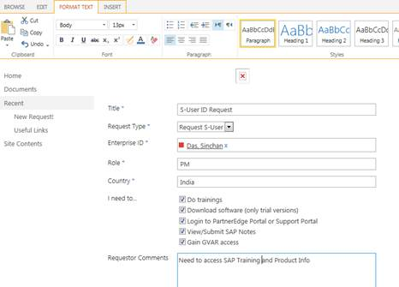

3.       You will get S-User id and Passwords in 48 hours.

4.       Then you can login to Partneredge using S-User id.

